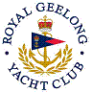 | Royal Geelong Yacht Club Inc.  Est 1859
Trophy Deed of Gift.

Trophy: | Mayfair Perpetual Trophy
Presented by: | Corio Meat Packing Co. (in favour Bob Jackson)
Date: | 1976
For: | J.O.G. Championship
Remarks / Revisions | Reallocated to Div II Outer Harbour Race

